Loop Statements in Python
Sometimes we may need to alter the flow of the program. If the execution of a specific code may need to be repeated several numbers of times then we can go for the loop statements.
A LOOP must have 3 statements:
- Initialization => Start Value
- Condition => Stop Value
- Increment / decrement => Step Value
In python, the following are loop statements
- while
- while True
- for
While
the while statement evaluates the given condition 1st then executes the related statements till the given condition returns TRUE.
Syntax:
initialization
While condition:
statement
statement
statement

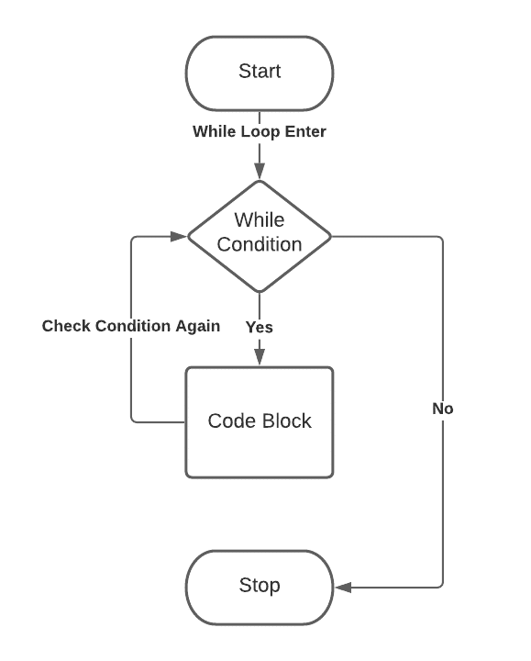

while True
This is an infinite LOOP executes the statements un-limited times.
break: this statement used to STOP the execution of the LOOP conditionally.
continue: this statement executes the statements beginning from the LOOP.
Syntax:
initialization
While True:
statement
statement
statement

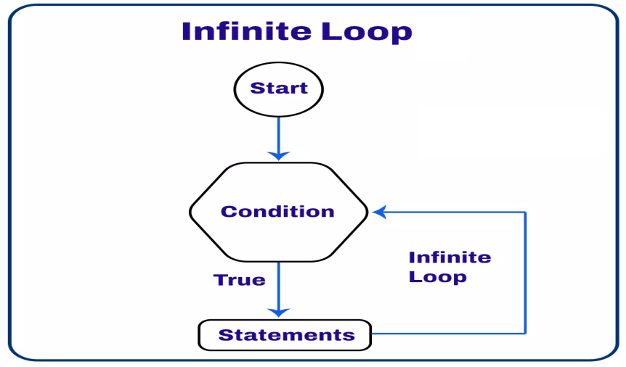

For
this is the easiest LOOP just because all the 3 loop statements contains in a single statement.
range(): this function used along with for LOOP to specify the Loop statements.
Syntax:
for <var> in range(init,condition,incre/decre):
statement
statement
statement

nested Loops:

a Loop written in another Loop

Outer Loop: for ROWS
inner Loop: for COLS
statement
statement
statement

# 1. printing natural no's
num = int(input("Enter a Number :"))

i=1 # init

while i<=num: # condition
print(i,end=' ')
i+=1 # incre

print("Loop Completed Successfully")

#2. printing even no's series
num = int(input("Enter a Number :"))

i=2 # init

while i<=num: # condition
print(i,end=' ')
i+=2 # incre

#3. printing odd no's series
num = int(input("Enter a Number :"))

i=1 # init

while i<=num: # condition
print(i,end=' ')
i+=2 # incre

#4. printing natural no's in Reverse Order
num = int(input("Enter a Number :"))

i=1 # initialization

while num>=i: # condition
print(num)
num-=1 # decrement

